Trees and Forests – Intro Notes
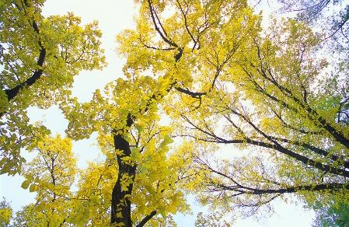

Trees are the world’s largest plants.
In order for a plant to be considered a tree, it must:
- Be perennial (lives more than 2 years)
- Have a self-supporting trunk
- Consist of woody material
Trees have a single woody stem, a root system, and a crown of branches and leaves.
- The woody stem (cellulose and lignin) gives the tree strength
- The roots collect water and minerals from the soil and transport these to other parts of the plant
- The leaves allow the plant to breath and allow for photosynthesis.

What is a forest?
What are the roles of trees and forests?
How are trees and forests important?

