[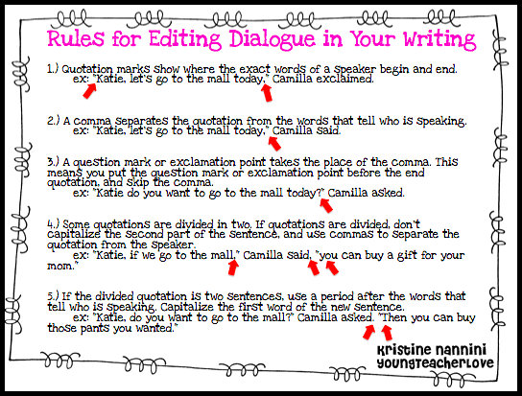](http://www.teacherspayteachers.com/Product/Teaching-Dialogue-in-Writing-Freebie)

[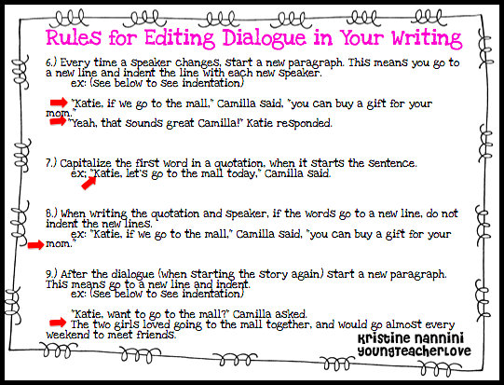](http://www.teacherspayteachers.com/Product/Teaching-Dialogue-in-Writing-Freebie)

[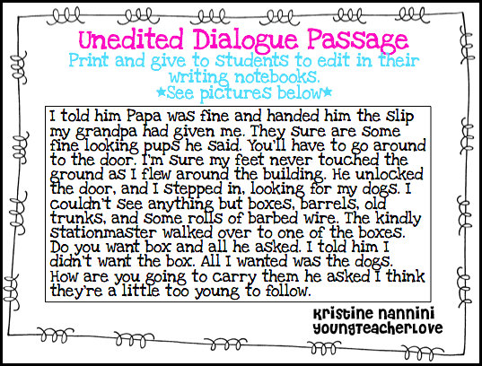](http://www.teacherspayteachers.com/Product/Teaching-Dialogue-in-Writing-Freebie)